大物实验数据 古宜民 2018/10/20

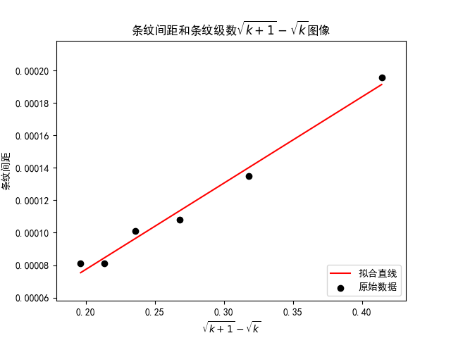

linear regression:   
 slope: 0.000532385   
 intercept: -2.91374e-05   
 r-value: 0.992488   
 p-value: 8.44329e-05   
 std-err: 3.2813e-05   
 r-squared: 0.985032   
 斜率标准差: 3.2813e-05   
 截距标准差: 9.32129e-06

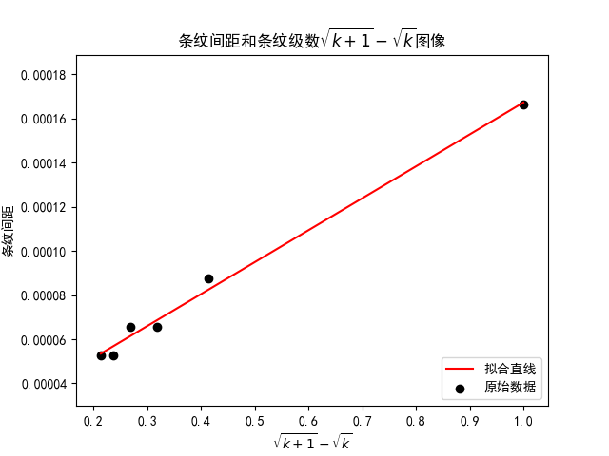

linear regression:   
 slope: 0.00014471   
 intercept: 2.25891e-05   
 r-value: 0.996179   
 p-value: 2.18676e-05   
 std-err: 6.34302e-06   
 r-squared: 0.992373   
 斜率标准差: 6.34302e-06   
 截距标准差: 3.11354e-06  
